

**Detailed Design**

**USC** CSCI 201

**1. Architecture**

**1.1 System Architecture**

• *Whiteboard* shall run on a hardened and updated cloud server running Ubuntu 14.04 x64.

• The system shall use NGINX for request routing and for serving static content.

**1.2 Application Architecture**

• *Whiteboard* shall be served by a Java application that will handle requests delivered from the frontend and interact with the database backend.

• The application frontend shall be compatible and optimised for modern supported desktop and mobile browsers.

**1.3 Hardware Requirements**

• The minimum hardware requirements shall be 512MB memory and 20GB storage.

**1.4 Software Requirements**

• The Java application shall run on Java 8 and later.

• The database backend shall utilize an InnoDB instance of MySQL.

• The application frontend shall employ the use of JavaScript EMCA 5, CSS 3, and HTML 5.

**1.5 Whiteboard Functionality**

• The client will generate a bitmap image whenever a user draws on the whiteboard, to be sent to the server.

• This bitmap will consist just of the user’s added drawing and not the entire whiteboard.

• The server will merge the bitmap with the server-side bitmap of the current whiteboard, so as to save the changes.

**2. Inheritance Diagram**

cs201 inheritance.png

**3. Database Schema (ER Diagram)**

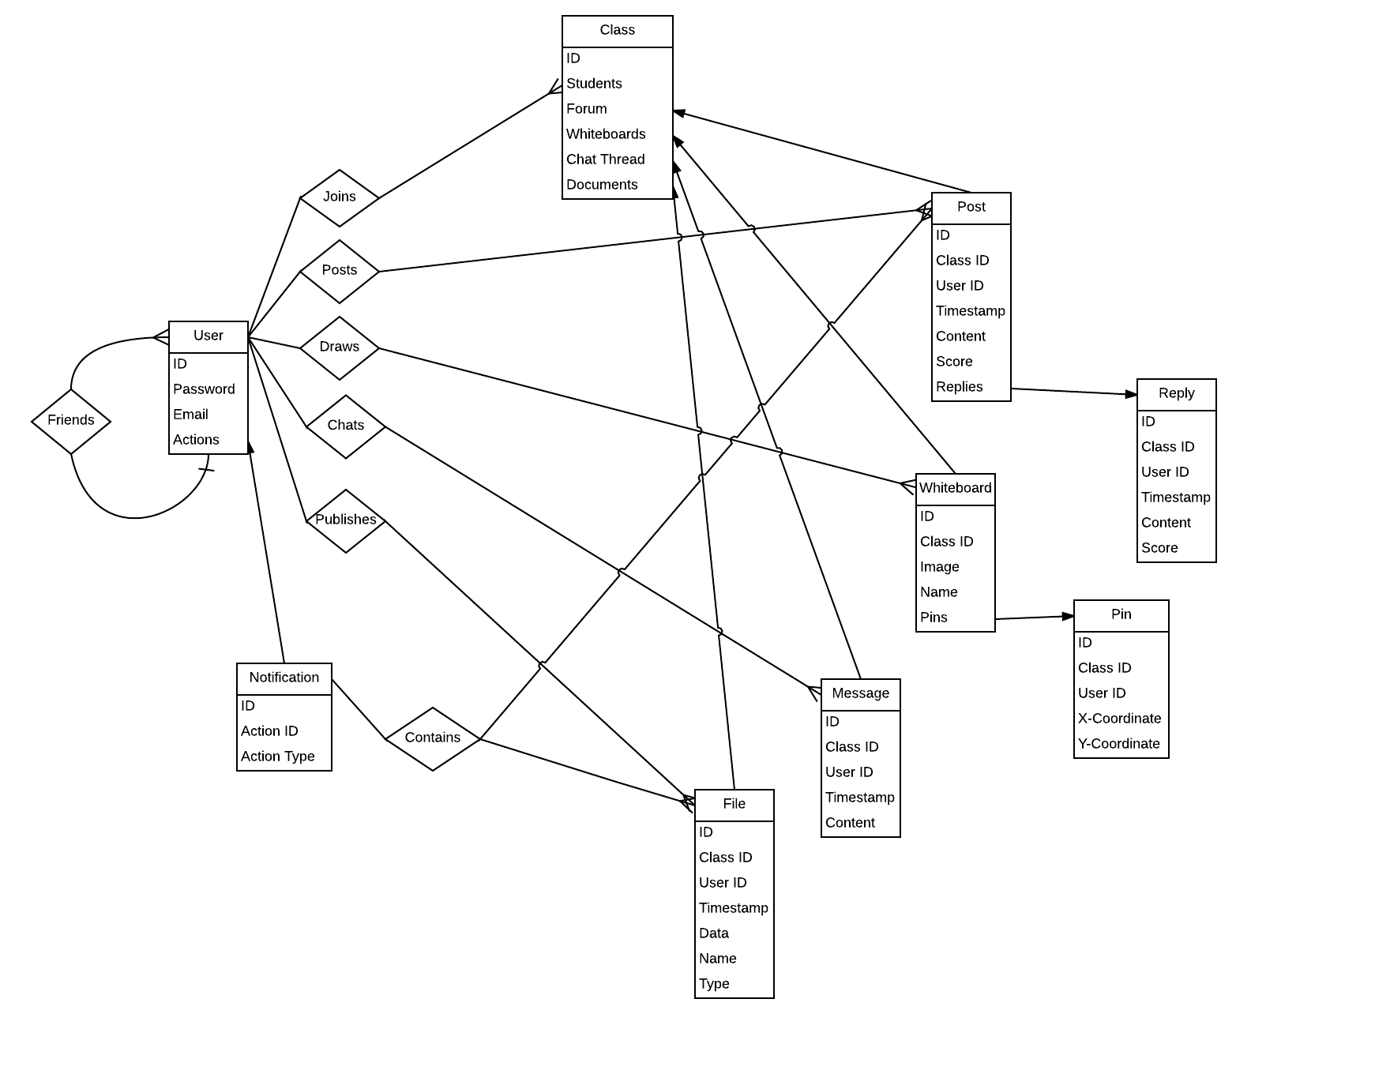

**4. User Interface Mockups**

**4.1 Landing Page**

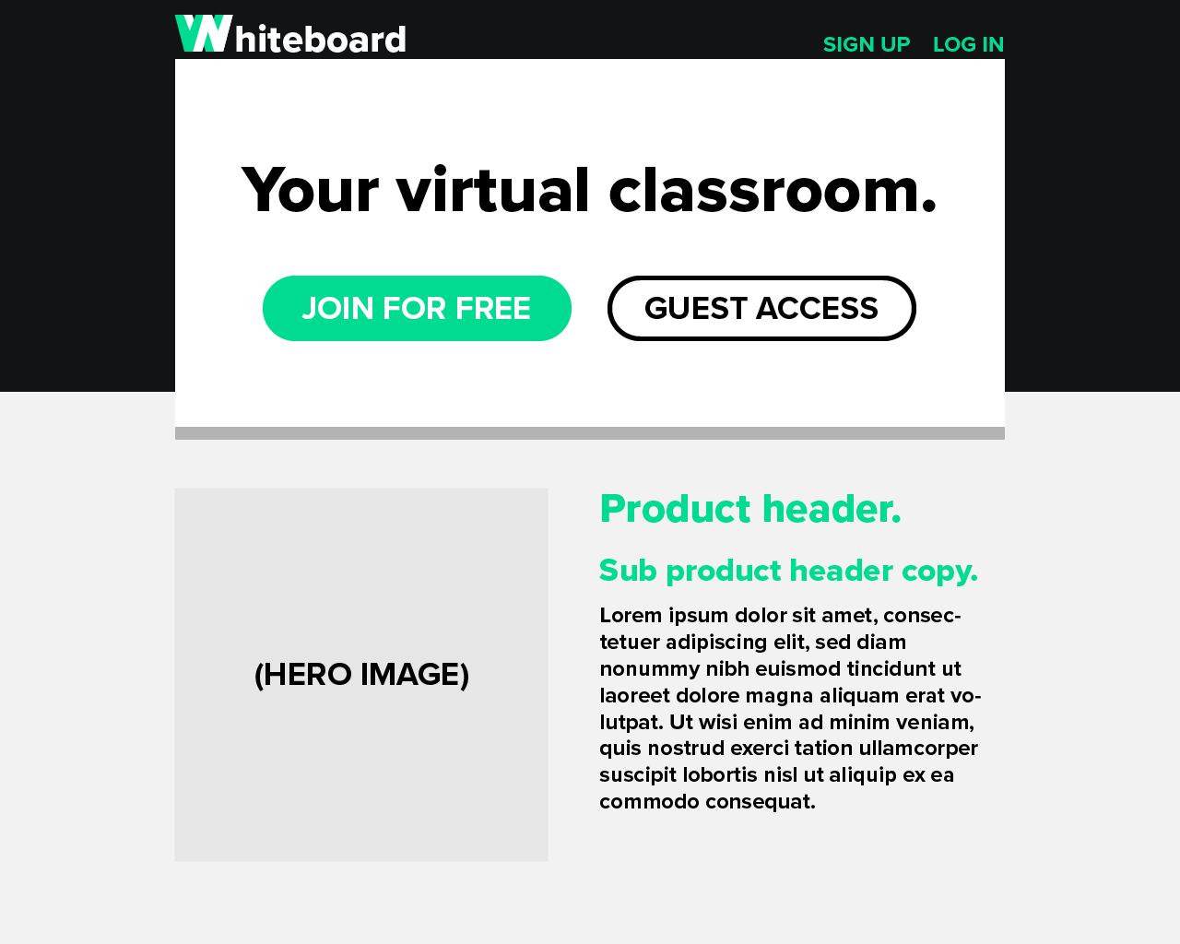

**4.2 Homepage**

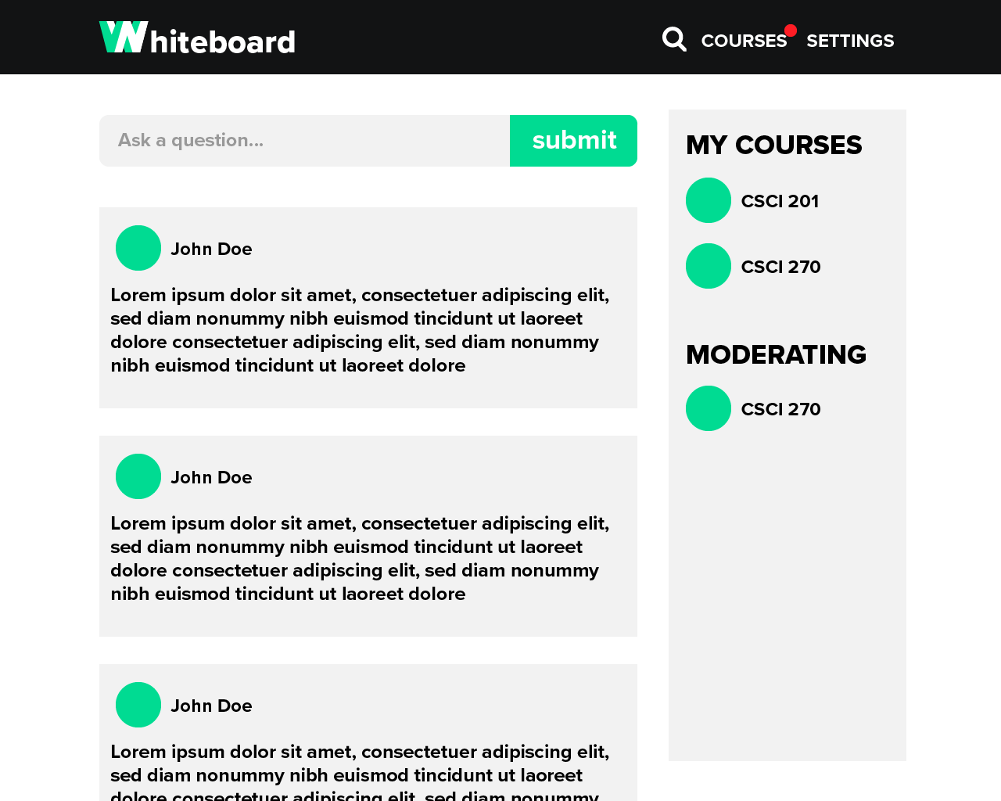

**4.3 Course Whiteboard Page (with Chat Module)**

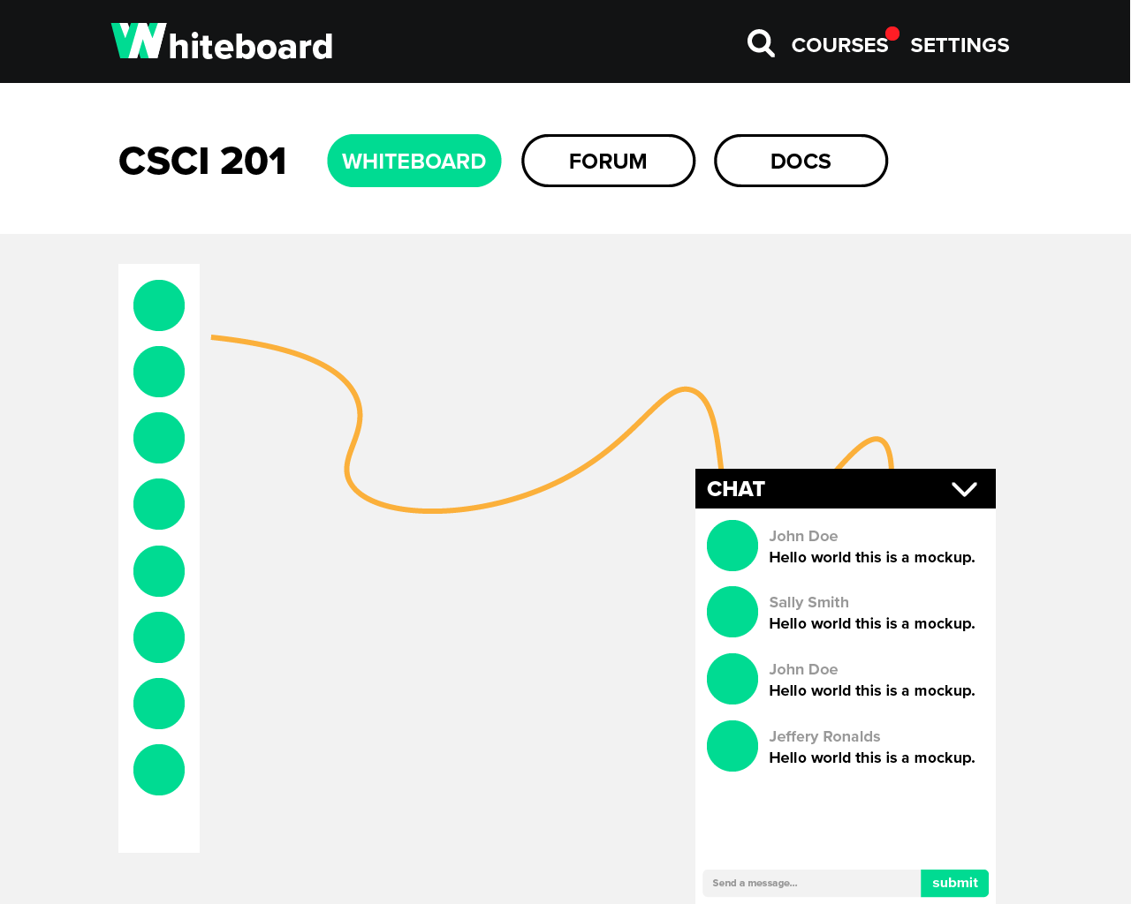

**4.4 Course Forum Page**

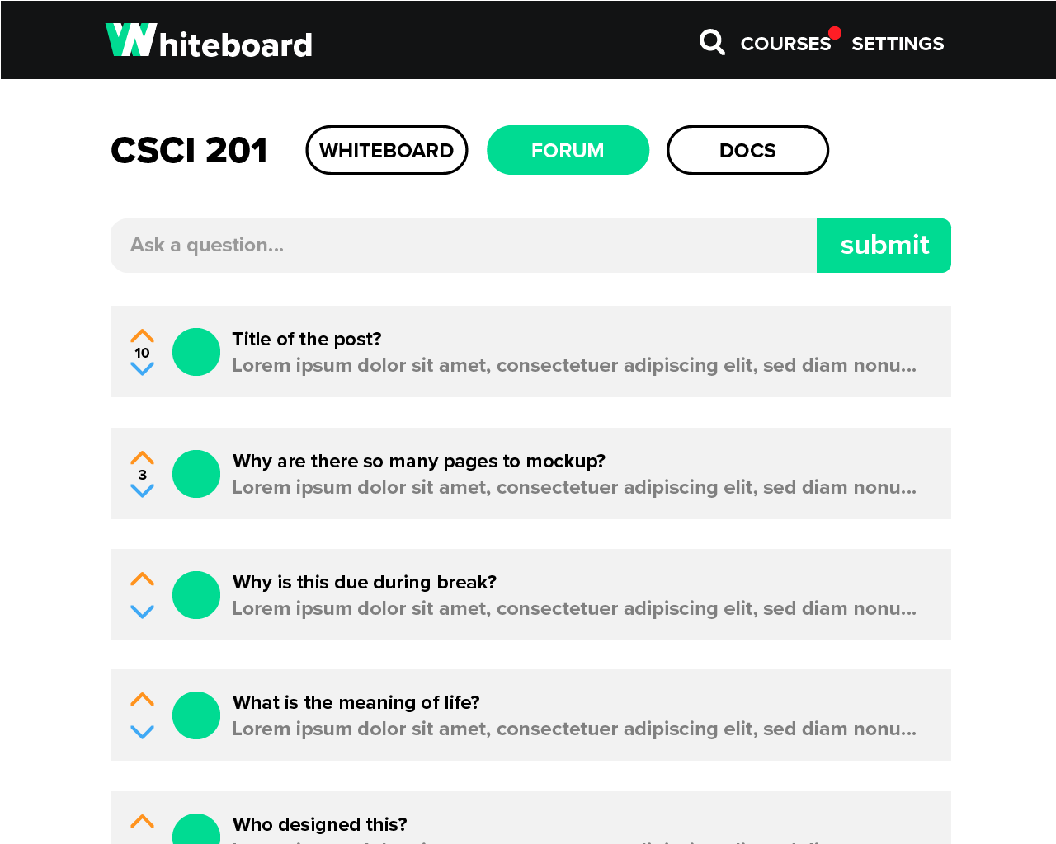

**4.5 Forum Post Page**

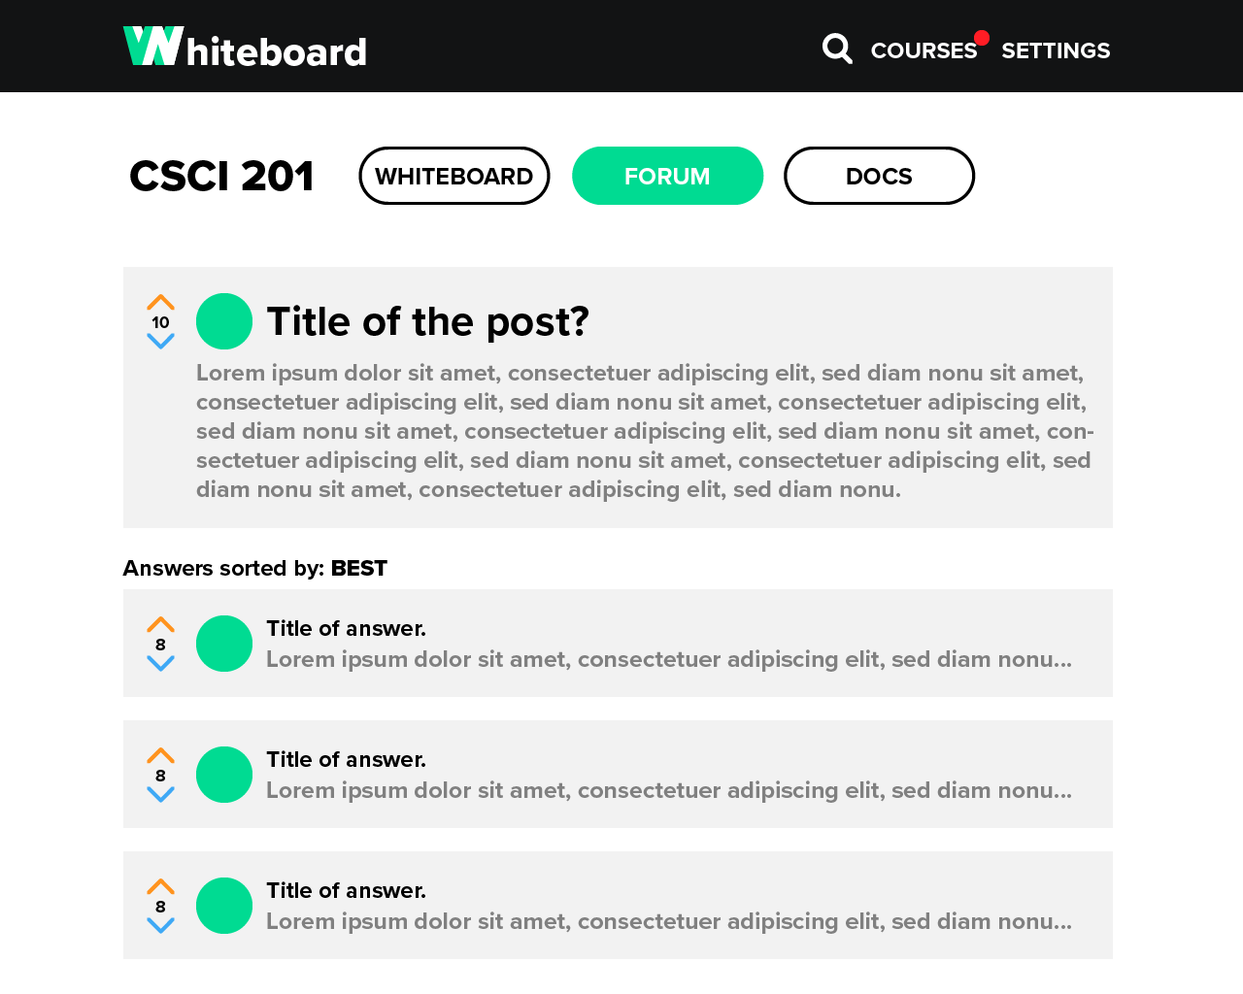

**4.6 Course Documents Page**

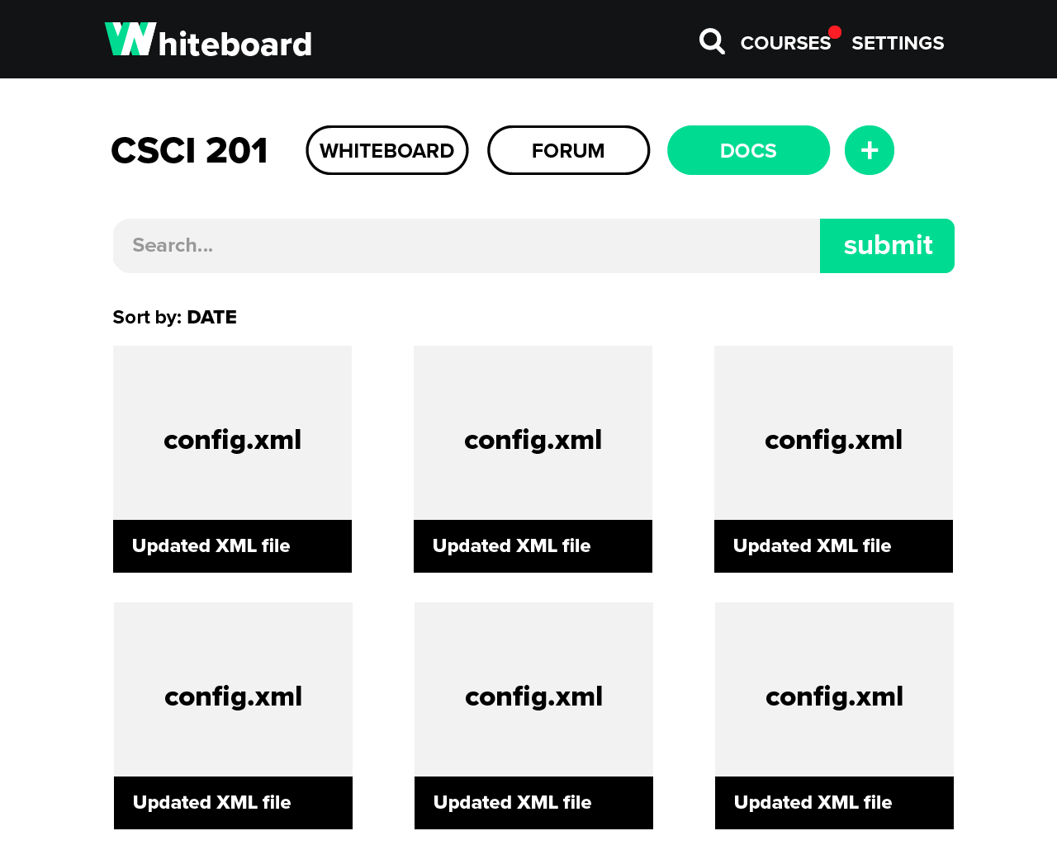

**4.7 User Profile Page**

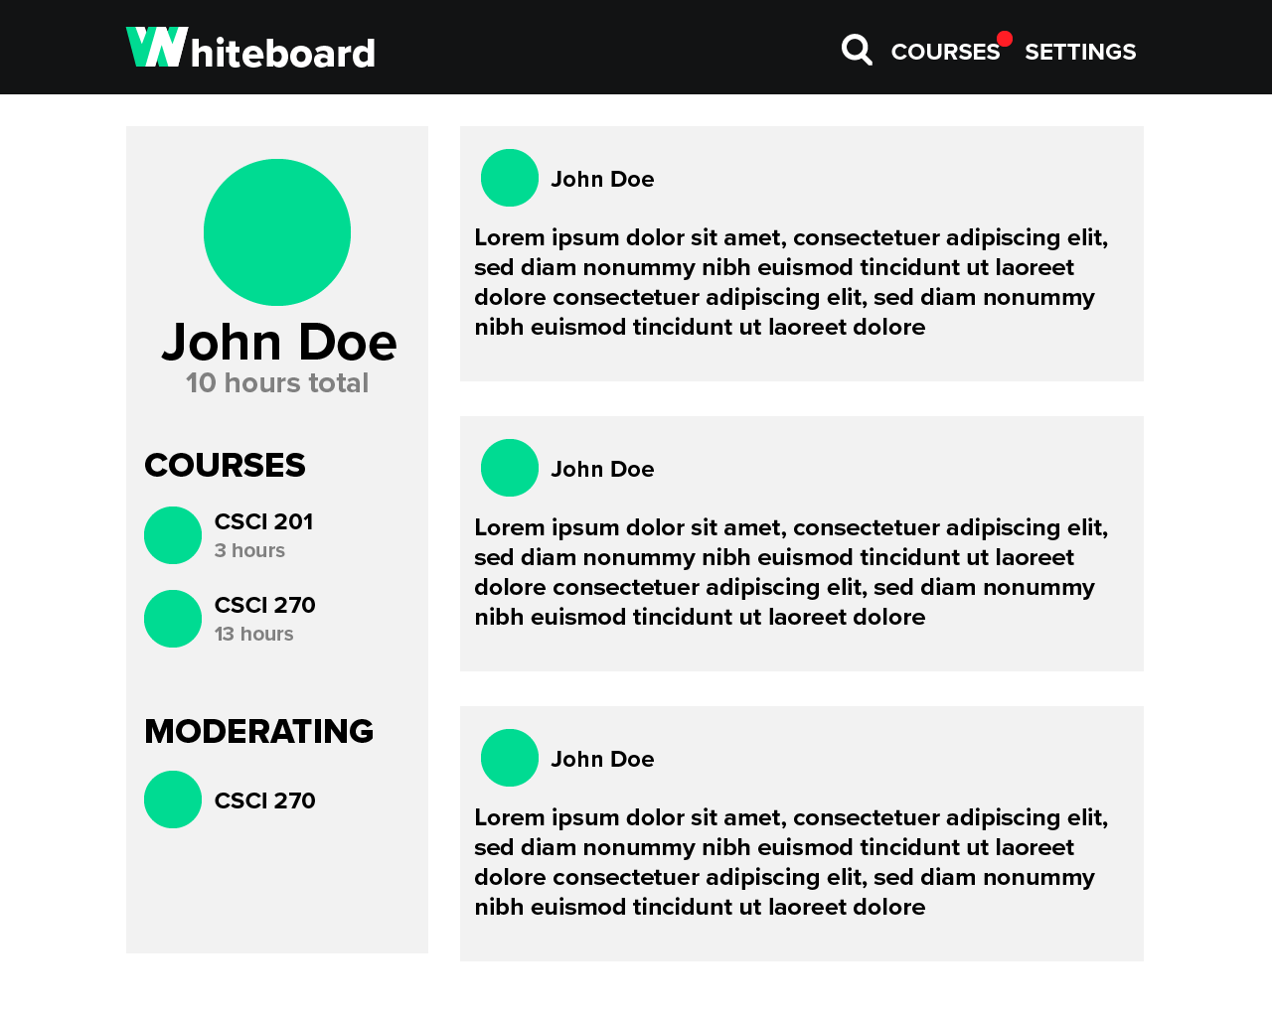

**4.8 User Settings Page**

